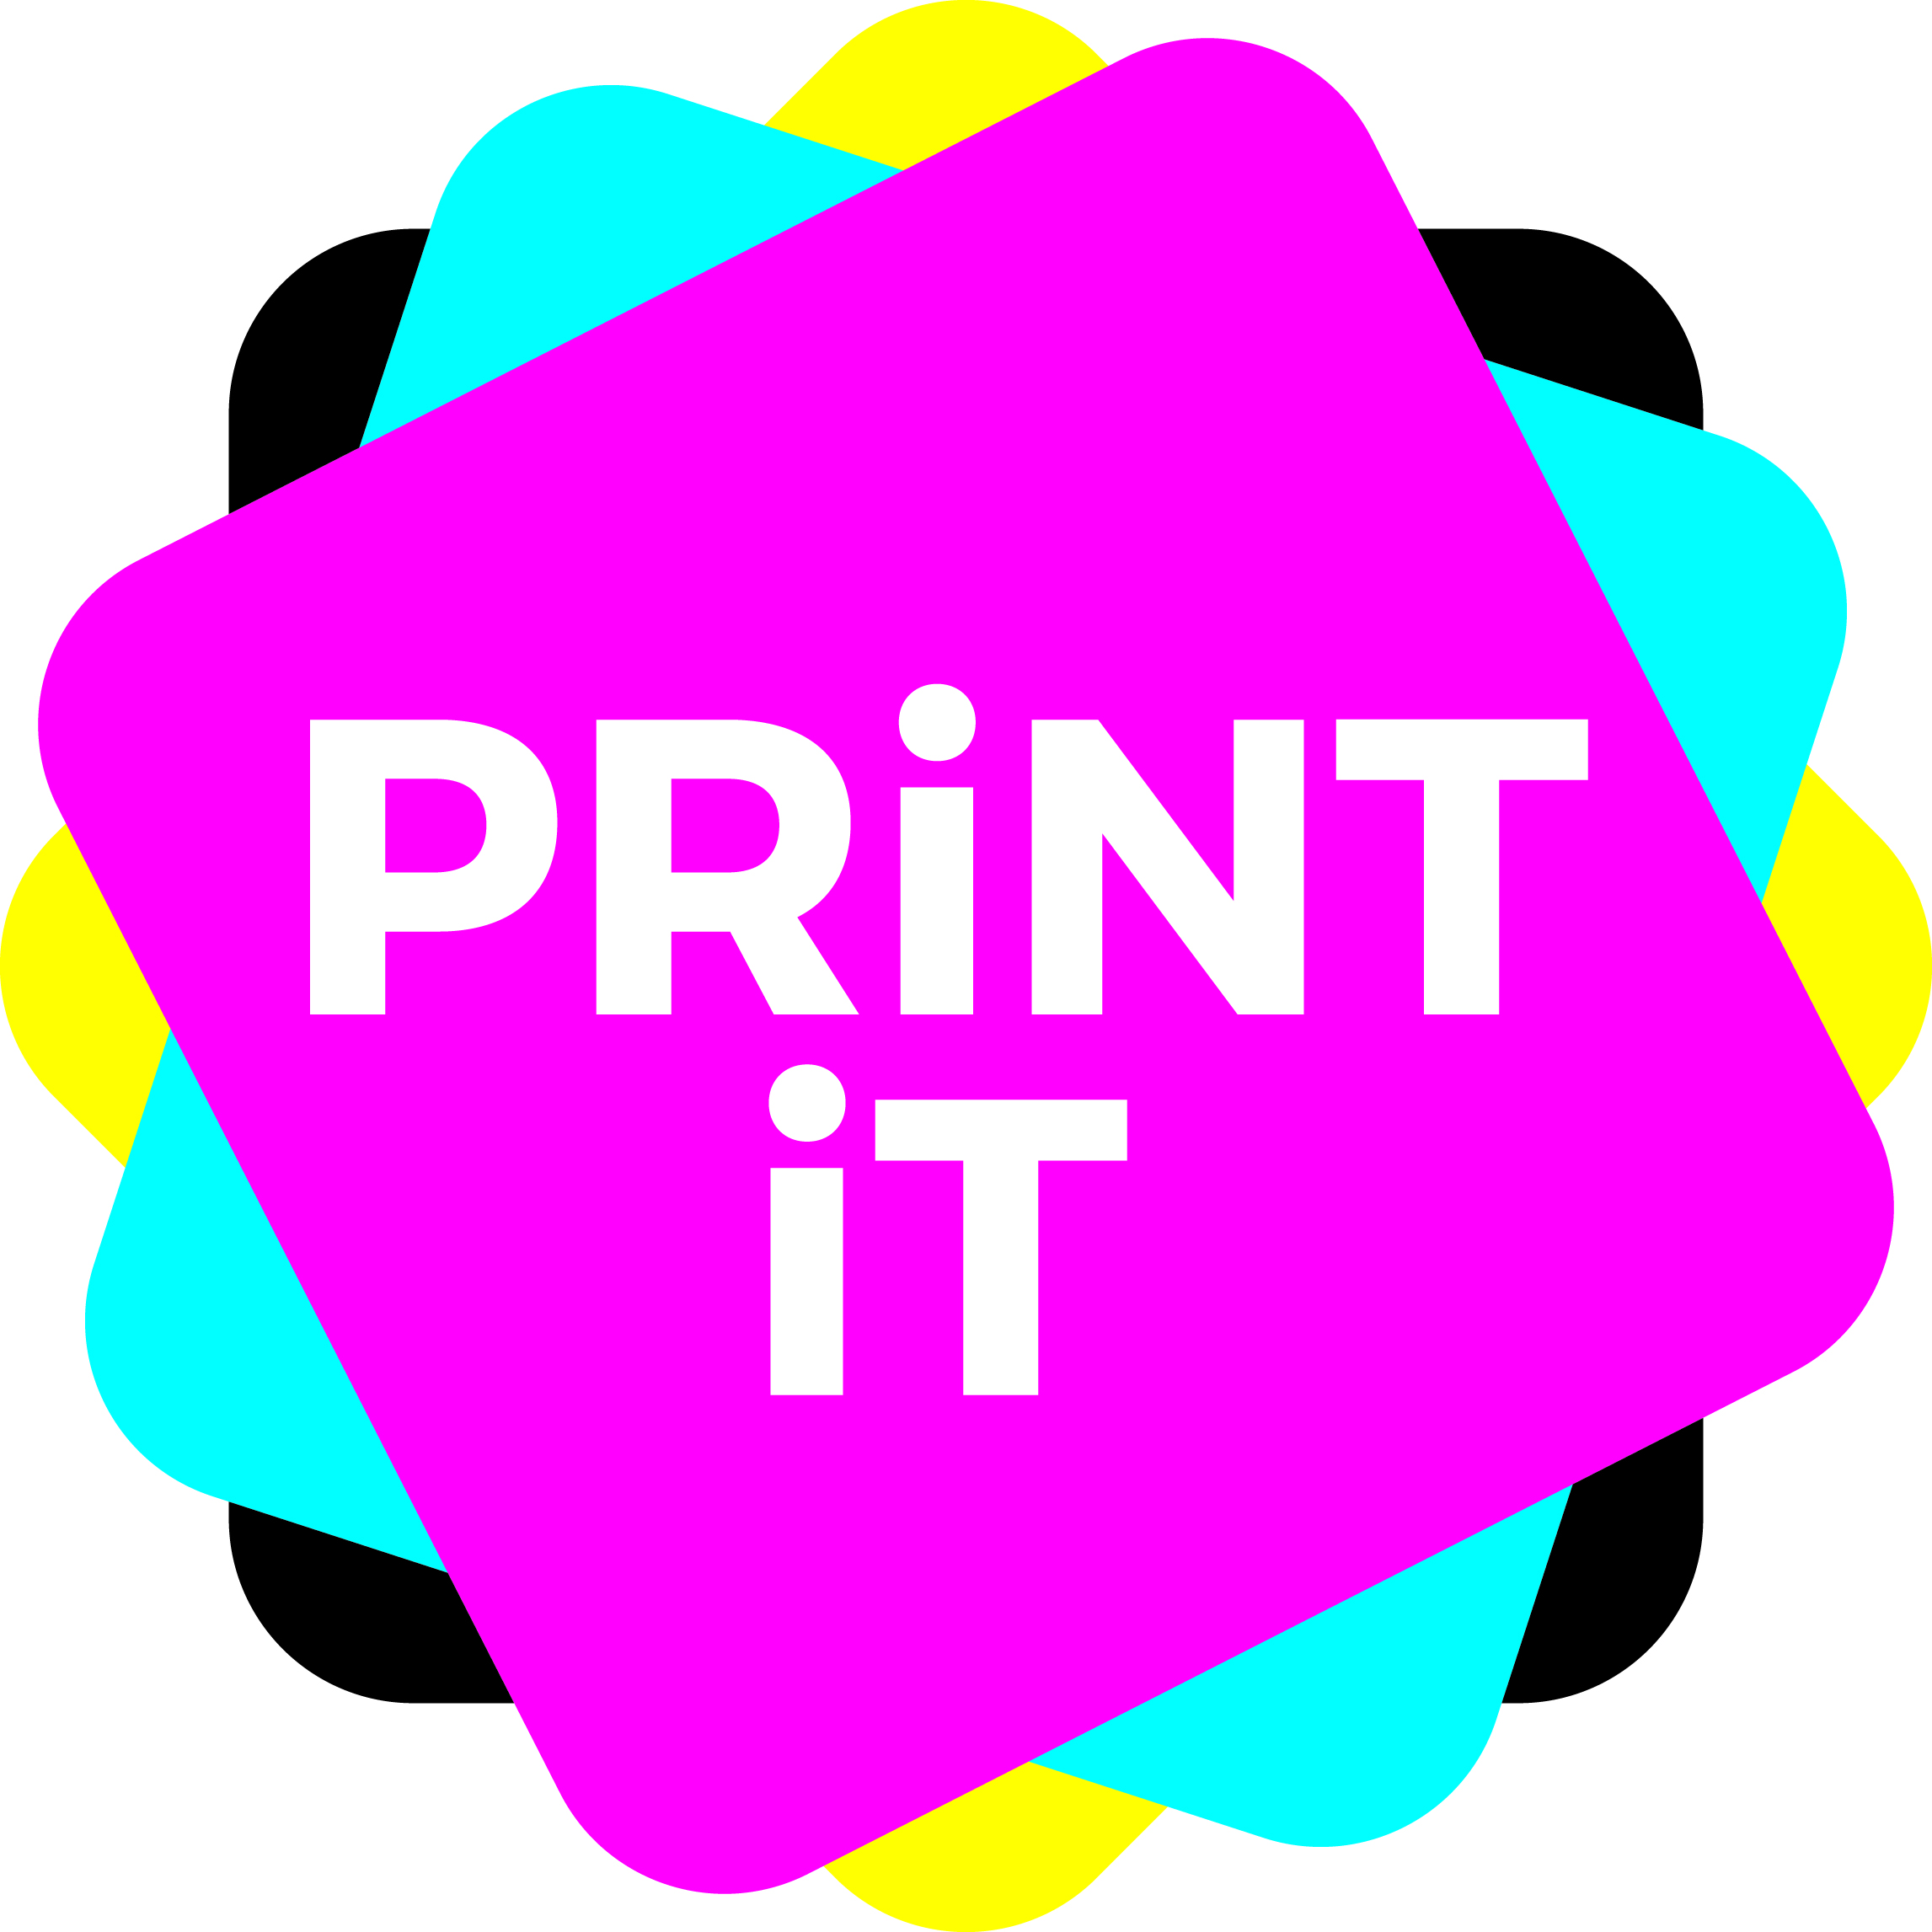
Brand guidelines

When choosing a brand name, there are a number of things that you need to consider. These are the top six.

- It has to be original. You can’t name your business after an existing company that has trademarked its name (Coca-Cola, Tesco, Ebay). However, there are lots of companies that have similar names, so check around (a search on the internet for instance, or look at Companies House website) to see what other companies use the name. If there are not in the same sector as you, or the name is slightly different, or they are in a different country, it may be okay to go with your brand name.
- Make sure it is memorable, but make sure it is appropriate for what you do, but that you can also still use it if you expand into different areas. You can always spell a ‘usual’ word in an ‘unusual’ it in a distinctive manner – changing up ‘s’ for ‘z’ for example, or adding a number into the letters.
- Make sure that is both easy to spell and say. WXYZQPVBXYUHZQ for instance, is not a good option!
- Make sure it has no negative aspects in another language. You can do this by putting it into an online translator.
- Keep it positive.
- Before you choose your name, develop your brand strategy. Which business line are you going to choose – sports, gaming or music. What sort of ‘products’ are you going to produce? What sort of company ethic are you going to have – is it a serious business that you want to look ultra professional and corporate, or do you want to be a fun and friendly company that is more casual?

Naming conventions
There are several ways to go when brainstorming your brand name:
You can use the founder’s name (WH Smith, Sainsbury’s, Ralph Lauren)
You can use a name that describes what you do (The Body Shop, Booking.com, Netflix)
Or, a simple descriptive name (Orange, Fab, Rover)
You can use a name inspired by classical culture (Nike, Argos, Ambrosia)
Or, one inspired by nature (Amazon, Fox, Sky)
You can take a word out of context (Apple, Subway, Gap)
You can make an acronym (EDF, BBC, KFC)
You can make an unusual connection (J2O, Red Bull, Um Bongo)
Or, you can make up a word (Google, Adidas, Microsoft)

Brand colours
Choosing the right colour for your brand and its logo is very important.
The most recognisable brands in the world can be recognised by their colours (think of Coke, Cadbury’s, Facebook, Fanta).

