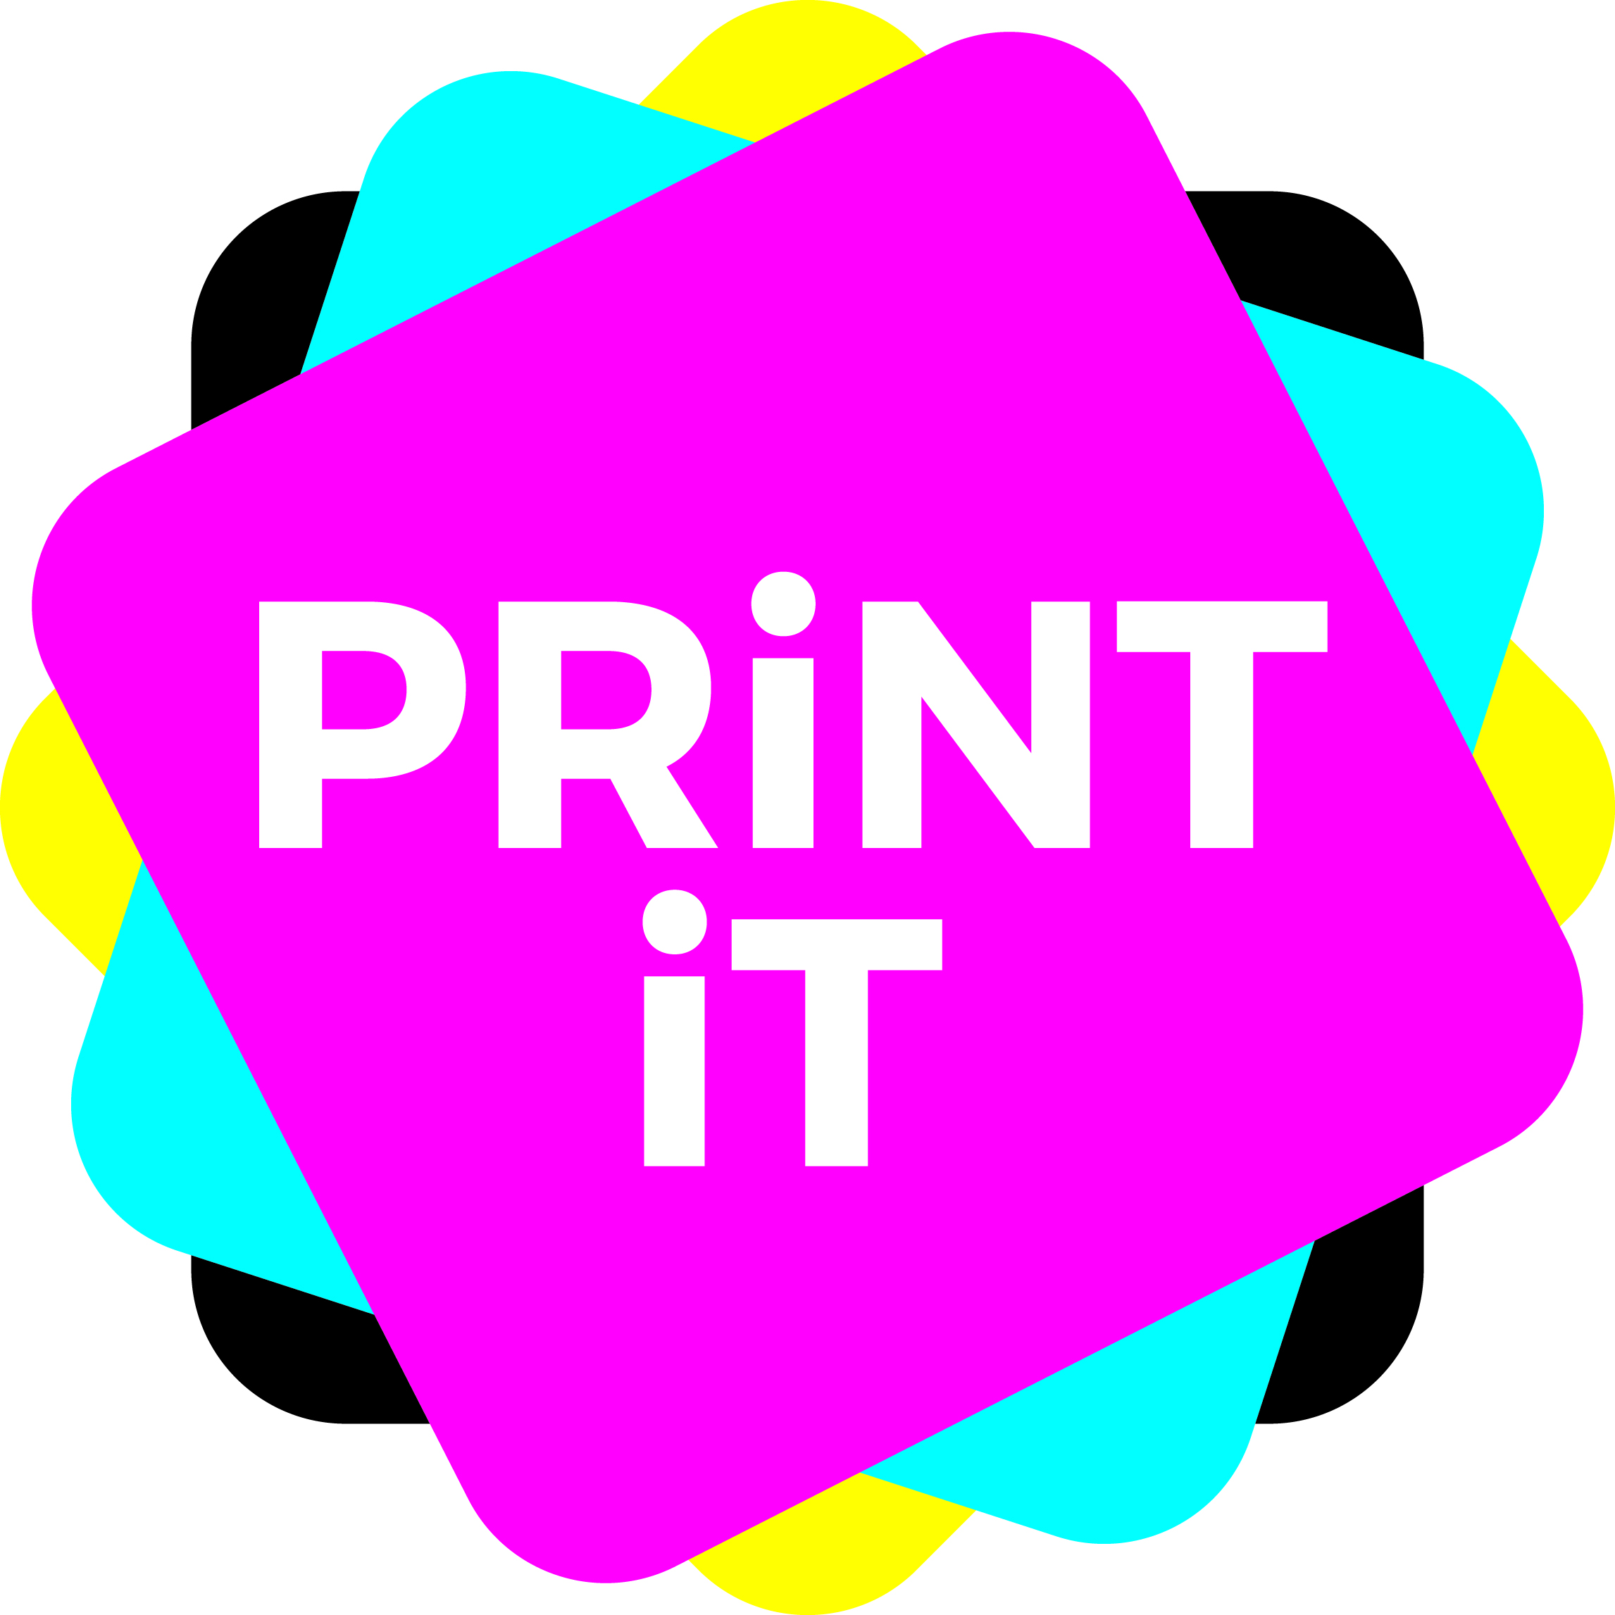
The truth about recycled

Recycled paper, in many cases, is perceived as being not high quality, it doesn’t run well, causes dust on the press and more. Yet, in reality, if you use a good recycled paper, it doesn’t suffer, or make you suffer, from any of these problems. In fact, it can be very high quality and give you a great finish. It runs well without dusting and will produce your project just as well as paper made from virgin fibres. You shouldn’t be able to tell the difference on press or off it.

Probably the main benefits of recycling and reusing paper fibres is that it removes waste from landfill. And, it provides a valuable raw material for paper makers to remake papers several times without having to introduce virgin fibres into the production process.

Lots of research has been done about the actual recycling and deinking process and the remaking of paper, its energy and materials use. Is this more environmentally friendly than making paper from virgin fibres or not? And what do you really mean by recycled content?

Recycled stocks are made from either post consumer waste or pre consumer waste. For clarity, post consumer is paper that has already been used by the consumer either having been made into a product or printed upon in some way – such as office waste, old newspapers and magazines, direct mail, and more. Pre-consumer waste is paper that has been made but for one reason or another has not made it into the consumer chain – things such as mill broke (waste created in the actuall paper manufacturing process itself such as when a web tears, or there is a stoppage on the machine), paper trimmings or other scrap from the manufacturing process.
Recycled fibres can be reused between four and six times before they become too short and brittle to make paper – and each time they are recycled they degrade somewhat, but can still be used for lesser qualities. For instance, recycled fibres can remake office or commercial printing paper and when recycled again can make newsprint, then higher quality packaging and corrugated, then cores and things like egg boxes. This of course means that at some stage virgin fibres must be introduced into the overall paper making chain to ensure continued supply.

There has been lots of comment about recycled paper manufacture using more energy that virgin makings. Reports from various associations do not substantiate this. For instance the American Energy Information Administration says there is a 40% reduction in energy between recycled and virgin makings (in recycled’s favour), whilst the Bureau of International Recycling goes further, claiming a 64% reduction. However, there are many other associations that say that making paper from recycled fibres consumes more energy than virgin! So, you have to take an overall view and say that at very least recycling paper means less landfill – and that at least is fact!
The BIR also points out that it is not just energy, however, but remaking paper from recycled fibres can also save on water and air pollution, as well as the resultant 750 kg of CO2 that would go into the atmosphere for every one tonne of paper burned.

According to a report from the International Council of Forest and Paper Associations the global paper recycling rate stands at about 58%. Some developed countries have achieved as high as 70 to 75%. Many developing countries are establishing infrastructure to help improve paper recycling rates. (It should be noted here that there will never be a 100% recycling rate for paper, no matter how good we all are, for there are uses which mean that the paper will not go back into the waste stream. Things such as books that you keep for years, or archival papers, or tissue, loo roll and hygiene products, or cigarette papers which get burnt – it is estimated that around 20% of paper falls into this category).

Recycled fibres are a very important resource for paper makers, and as such encourage a greener manufacturing process.

What happens to my old paper?
First paper products are sorted and shredded, then mixed with water and to make a ‘pulp’.
It is then deinked. There are various methods of doing this such as flotation deinking and washing.
Flotation deinking, the most common process today, uses chemicals that create small bubbles and allow the hydrophobic components such as ink to float to the surface, forming a kind of ‘foam’ that can then be removed.
Sometimes a second stage flotation process is used depending on the pulp specification.
The washing process allows the removal of inks and other elements such as mineral fillers through washing the pulp on a wire screen. This is most effective when there are only small particles of ink to be removed.
The fibres are then often bleached to make them appear whiter.
It is estimated that ink accounts for about 2% of the total weight of the paper being deinked.

