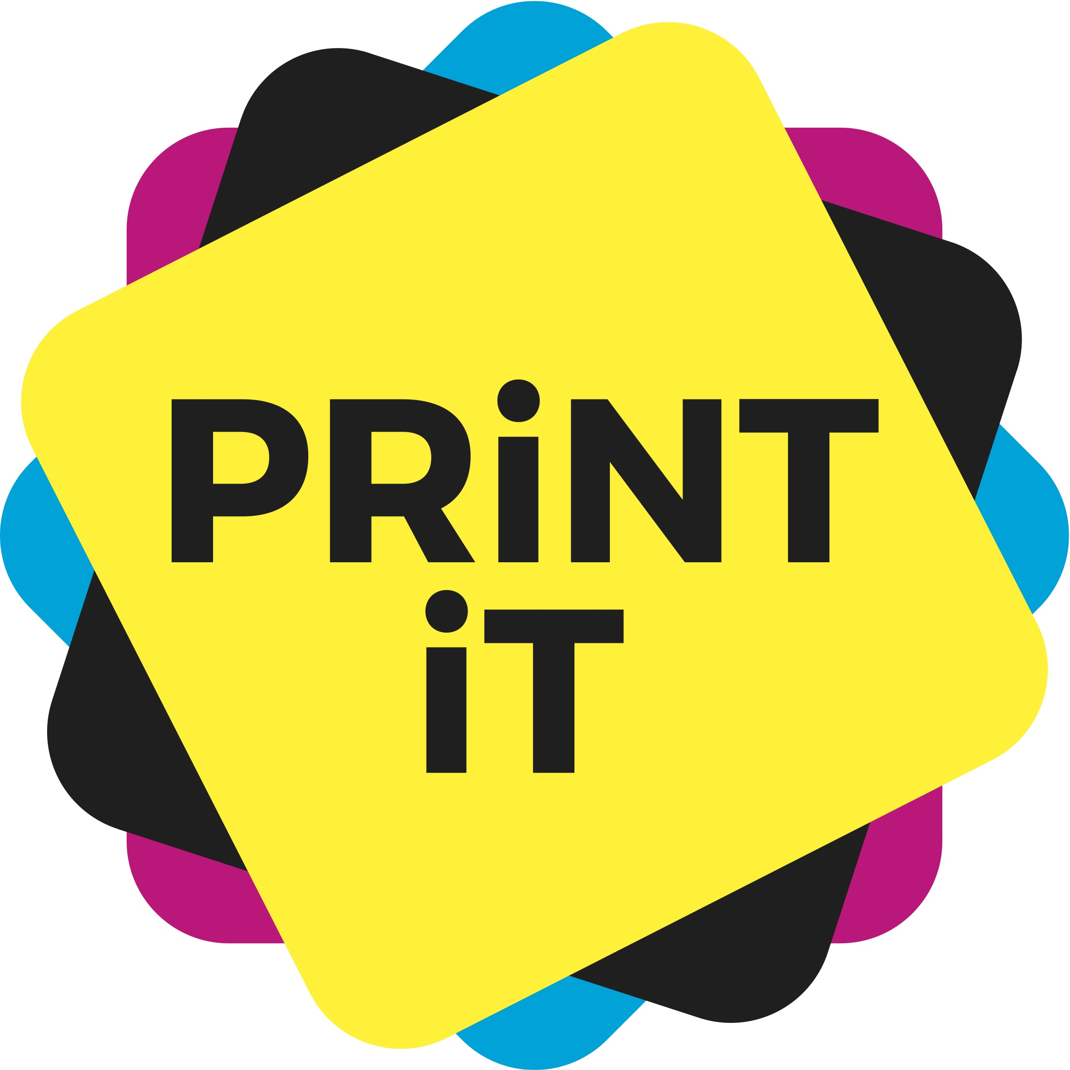
Logos and labels

ISO 14001
ISO 14001 sets out an internationally agreed framework for an environmental management system through which a company can become certified. It is applicable in any sector and any industry and for companies of all sizes.
Its criteria include environmental performance, efficient use of resources, reduction of waste and the monitoring and control of those things. It covers, amongst others elements, air pollution, water and sewage issues, climate change mitigations and more.
Like all ISO systems, it requires the need for continual improvement within the certified company.
The certification is not carried out by ISO, but by independent, third party agencies.
www.iso.org

PEFC
The Programme for the Endorsement of Forest Certification (PEFC) is a non profit, non governmental organisation that has certified more forest area than any other forest certification scheme. At time of writing, the organisation has certified more than 270 million hectares of forests in 36 countries. More than 17,000 companies have obtained PEFC chain of custody certificates globally.
The PEFC logo stands as a mark of trust that certified forests are managed sustainability – forests are certified through independent third parties. The organisation works throughout the entire forest supply chain to promote good practice and to ensure that timber and non-timber forest products are produced with respect for the highest ecological, social and ethical standards.
PEFC states that it emphasises ‘a ‘bottom up’ approach, whereby national certification systems are developed independently and come together under the umbrella of PEFC’.
‘Chain of custody’ means that the product can be tracked and traced from the forest floor through to final product through the whole supply chain.
www.pefc.org

FSC
The Forest Stewardship Council (FSC) is a non profit organisation dedicated to promoting responsible forestry. Products made from the resources in these forests can carry the FSC label as an assurance that the forest is managed to high standards in a manner that is ‘environmentally appropriate, socially beneficial and economically viable’.
In addition to forest certification, the FSC system includes a certified chain of custody that tracks the timber through every stage in the supply chain from the forest to the final user.
Certifications are carried out by independent third parties.
The FSC label is currently found on over 10,000 product lines in the UK alone, and this includes paper and printed products. The labels can also be found on some non timber products that are also derived from the forest.
At time of writing, the organisation has certified more than 187 million hectares of foreset with more than 30,000 chain of custody certificates globally.
www.fsc-uk.org

EU Ecolabel
The EU Ecolabel helps identify a wide range of products and services that have a reduced environmental impact throughout their full lifecycle, from the extraction of raw material through to production, use and disposal. It is not industry specific to the graphic arts supply chain.
The criteria have been developed and agreed upon by scientists, NGOs and stakeholders and it involves certification of a product as well as compliance checks by independent consultants.
The EU Ecolabel for Printed Products guarantees: low air and water pollution during paper production and printing process; reduced environmental damage or risks related to the use of hazardous chemicals; increased recyclability.
It can be awarded to any printed paper product that consist of at least 90% by weight of paper, paperboard or paper based substrates, except for books, catalogues, pads, booklets or forms that should consist of at least 80% by weight of paper substrates.
The EU Ecolabel for Copying and Graphic Paper guarantees: low air and water pollution during production; hazardous substances restricted; use of certified fibres from sustainably managed forest.
It can be awarded to sheets or reels of unconverted, unprinted blank paper and boards used for printing, copying, writing or drawing. News- print, thermally sensitive paper and carbonless paper are not included in this product group.
www.ecolabel.eu

EMAS
The Eco-Management and Audit Scheme (EMAS) is a voluntary management tool for companies designed to evaluate, report, and improve environmental performance.
It is a requirement of the scheme that companies regularly produce a public environmental statement that reports on their environmental performance. The information has to be checked by an independent environmental verifier.
EMAS sits hand in hand with other environmental certificatons.
http://ems.iema.net

Blue Angel
The Blue Angel (Blauer Engel) is an environmental label organised by the federal government of Germany for the protection of people and the environment. It sets very exacting standards (lifecycle), is independent and has been awarded to some 12,000 environmentally friendly products and services.
www.blauer-engel.de

Nordic (Swan) Ecolabel
Analysing environmental impact from cradle to grave, the Nordic Ecolabel specialises in products in paper, print and pulp (it does also set its criteria to other related products too such as chemicals for papermaking). It is also relevant to companies that are not in the Nordic countries.
This is a third party certified label with stringent criteria that must be met.
www.nordic-ecolabel.org

Green Dragon
The Green Dragon Environmental Standard was originally set up by Groundwork Wales, to help companies in Wales to develop an EMS in stages, but it quickly spread across the UK.
The standard is structured into five ‘steps’ to allow companies to gain recognition for their environmental progress even if they do not have a full EMS in place. Auditing is annual.
Level 5 of Green Dragon is comparable to ISO 14001.
www.groundwork.org.uk

Investors in the Environment
Investors in the Environment is a not for profit environmental accreditation scheme in the UK. It is designed to help businesses save money, improve energy efficiency and reduce environmental impacts.
It has three accreditation levels, so appropriate for any business looking to go green.
www.iie.uk.com

Green Achiever
The Green Achiever scheme offers accreditation also offer three levels of award, incuding a ‘self-assessed’ level.
The primary aim of the scheme is to provide a simple and effective means of communicating a business’ commitment to reducing its environmental impact.
www.greenachiever.co.uk

Carbon neutral
There are various carbon neutral, carbon ‘zero’ or carbon ‘free’ logos and badges. Most will show a compliance to decreasing or cutting out carbon impacts – usually through reducing existing impacts and then offsetting the difference through various schemes such as green energy and water initiatives.
Some of these labels only relate to a particular product or purchase, whilst others certify that the whole business is run at a carbon neutral level.
BSI (British Standards Institution) PAS 2060 is a trusted standard for carbon neutrality. It applies to organisations of all types and covers carbon neutrality across all areas including buildings, transport, manufacturing, product lines and more. If a logo bears the PAS 2060 mark on it, it is a verification of robust measurement, reduction and offsetting within a business.

What makes a good label?
- Independent third party auditing of the label – thereby making credible what it purports to stand for.
- The label should provide support and advice on what its parameters and criteria are ie where and what exactly has been measured – and what has not. Is it a complete lifecycle logo or just takes into consideration ‘part’ of the process/product?
- Transparency should be given when it comes to back up evidence of that label – scientific research, third party reports, standards limitations, clearly measurable and defined boundaries of what it stands for.
- Objectivity: Any label should include a variety of stakeholders in its instigation and no bias should be shown.
- Promotion: The label should be backed up with promotion to customers – and the wider world – to ensure that its worth is clearly understood.

All of the labels above fulfil these criteria.

