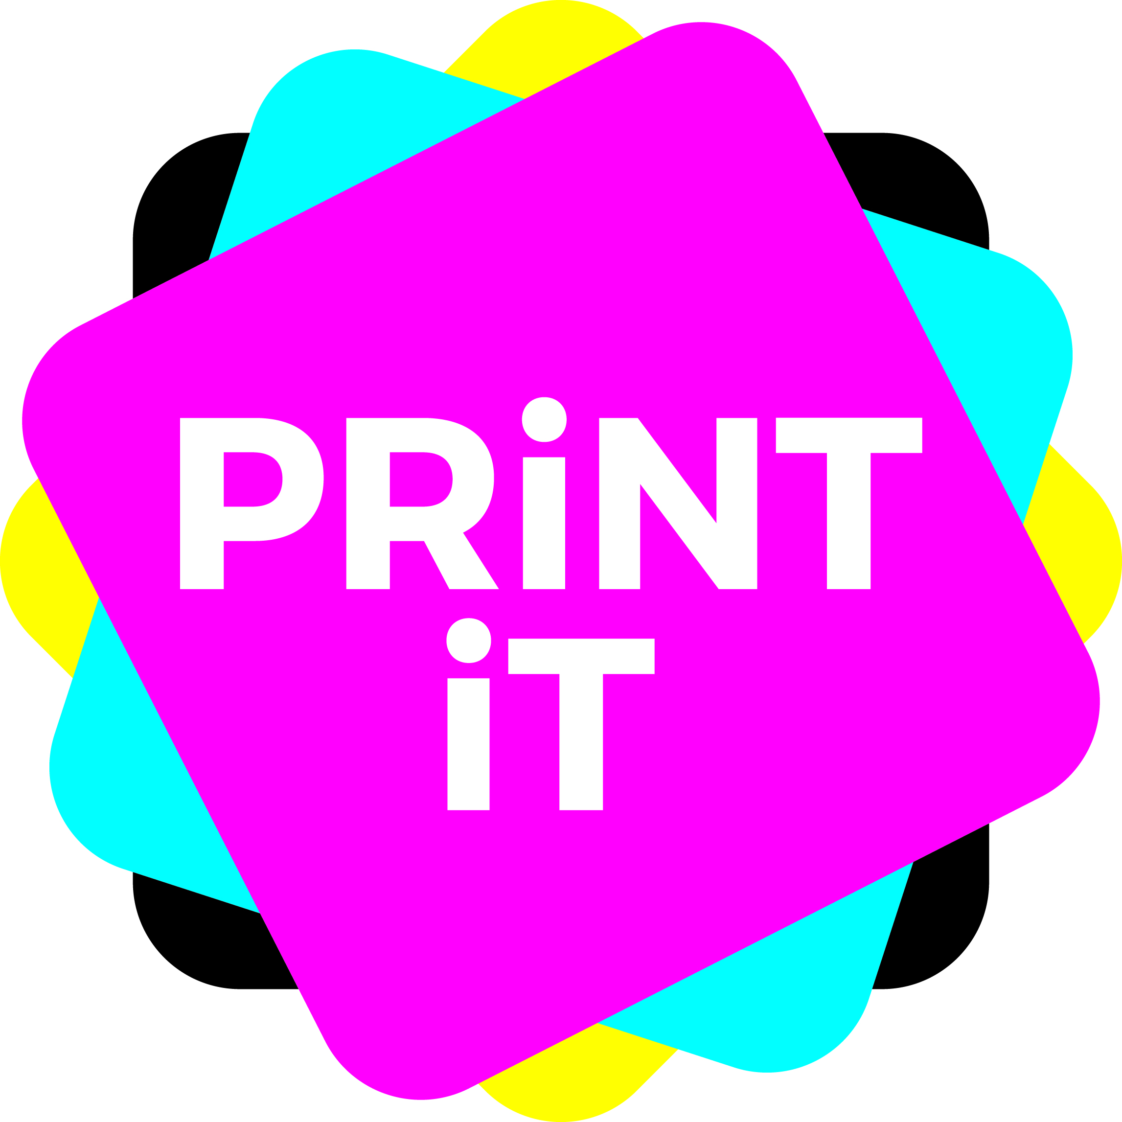
Why use multi-media for a campaign?

Multi-channel communication is not new. ‘Multi-channel’ has been used for many years (print, TV, radio, cinema, and more). However, it has only with the growth of the internet that the ‘true’ multi-media campaign has been arrived.

Multi-media campaigns embrace the strengths of both a print on paper message, back up by electronic communications and links to the web.

The internet had definitely encroached on the world of communications, but it has also offered opportunities and new strengths that printers can make more of.

Whilst marketeers were quick to be taken in by the alluring glances and fluttering ‘I’lashes of the new model of communication, they have quickly learned that a lot of it is bling and fake tan, and the comfy, warm and welcoming older, more trusted world of print still has its allure and can get a reaction that the internet never can.

‘The impact of the internet on print – The digital flood’, illustrates how many internet enabled tools such as web to print, variable data printing, interactive print such as augmented reality and QR codes and smart technologies such as printed electronics, will impact on most areas of the printing industry.

E-commerce is growing in most global regions at rapid rates. But, it works best if backed by print. For instance, the catalogue market publishers understand that print catalogues drive online.

Consumers are already switched on to, and excited by, interactivity via the internet and they are demanding more from their print. To show a disbelieving marketer the £10 note trick* brings interactivity and interest to print that makes people really sit up and take notice.

Multi-media marketing campaigns, with data acquisition/analysis and the use of several channels (for example, PURLs, e-mails, SMS, and hopefully some print elements – especially those with ‘smart’ interactive elements in them), are increasingly demanded by customers.

*The £10 note trick
This really is clever, and most people don’t even know it exists.
- Download the free Aurasma app onto your smartphone.
- Find a suitable person that you would like to prove the point that print is awesome to.
- Get a bog standard £10 note and place it on a flat surface with Charles Darwin looking up at you. (Important tip: If you have to borrow the note, please ensure you give it back!)
- Scan the note with the app and see print come to life!
- Be amazed. Charles Darwin will come to life, don a pair of sunglasses and tell you that this is the future of print, whilst the hummingbird will fly off. Stunning!
- If you find it impossible to find a £10, check out your back issues of Print Solutions – we have brought print to life on many of our covers.
- Use it to sell the benefits of interactive print to your customer.
- Get a whacking great order and buy me a pint next time you see me!

Sorry, David, I have just given away your party piece

