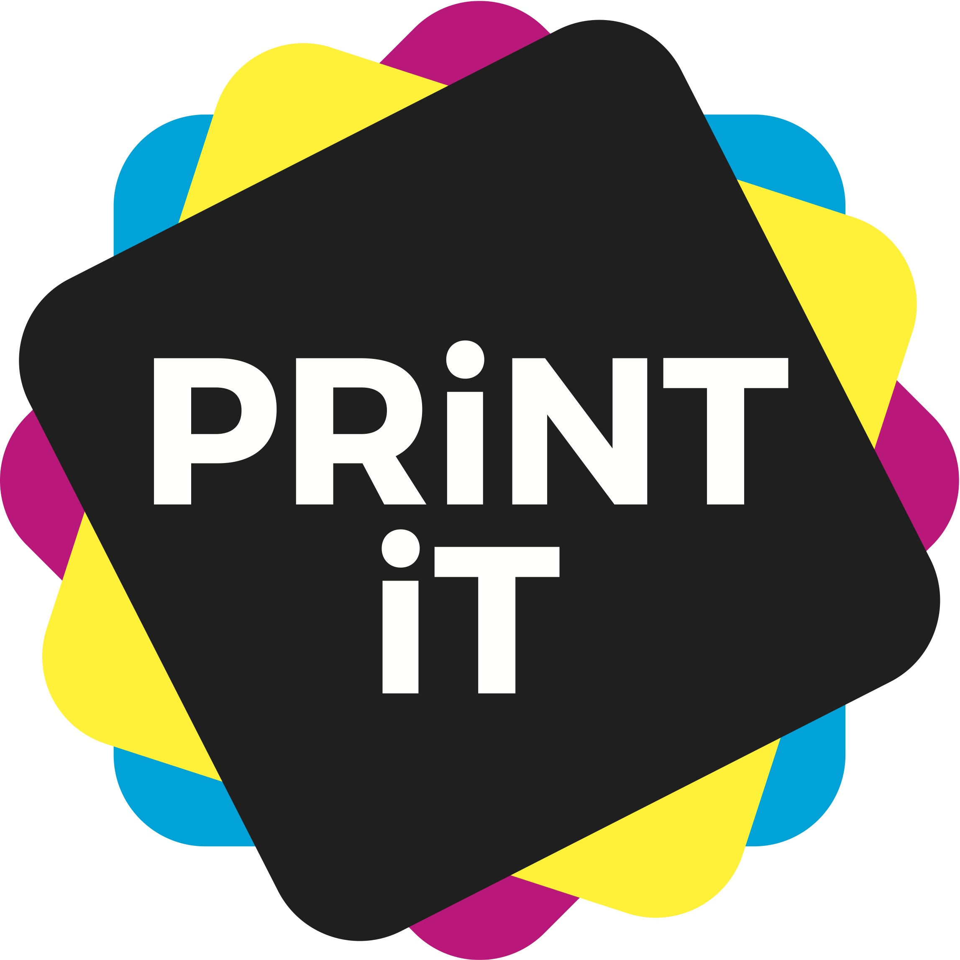
Top tips for designing an advert

1. Have a plan
Plan out what you need on your advert. Keep it clean and simple.
Decide on a clear message that you want to get across.
Make a simple sketch of where you want everything to go.

2. Choose an eye catching design
Make the centrepiece something eye catching that will get noticed.
You can experiment with images, graphics, cartoon, or word play, but make sure it stands out.

3. Think of something clever
See if you can find an idiom or saying that reflects your message. Don’t be afraid to play around with the words.
Don’t forget to start with a show stopping headline that will make people read on.

4. Choose the right colours
Rather than trying to use every colour under the sun, create a palette of complementary colours and shades that fit together well.
Stick to these, so that everything on the advert looks consistent.
Don’t forget that you will need to add your logo, so bear this in mind when choosing your colours.

5.Size is everything
Consider the size of your advert. If you are going for a full page, you will have plenty of room to experiment. But if you are designing a half or quarter page, or even a strip ad, you will have a lot less room and will have to make your message more concisee and catchy

6. Typography and fonts
Again, keep it simple. Do not use loads of different fonts – keep it clean with one (or maximum two).

7. Always, relate to your
Ensure your advert is suitable not only for your product, but also for the audience you are trying to engage. Bear this in mind whne choosing colours and fonts too.
For example, if you want a very ‘corporate’ ad, blues and greys are greta basic colours, whereas if you are trying to get to teenagers, bright colours may work better.

8. Have a ‘Call to Action’
This means that you ask the reader of your advert to do something. Then you will be able to see how ell it works.
This can be something like going to a website, or sending an e-mail for more information.
You can also get very clever by adding augmented reality – where the page comes to life, or QR code that can be scanned by a smartphone.

9. Don't forget
There are a few basics that you should always include your company name and logo, contact details or a website, a little information about the product that you are trying to sell – it only needs to be a strapline.

