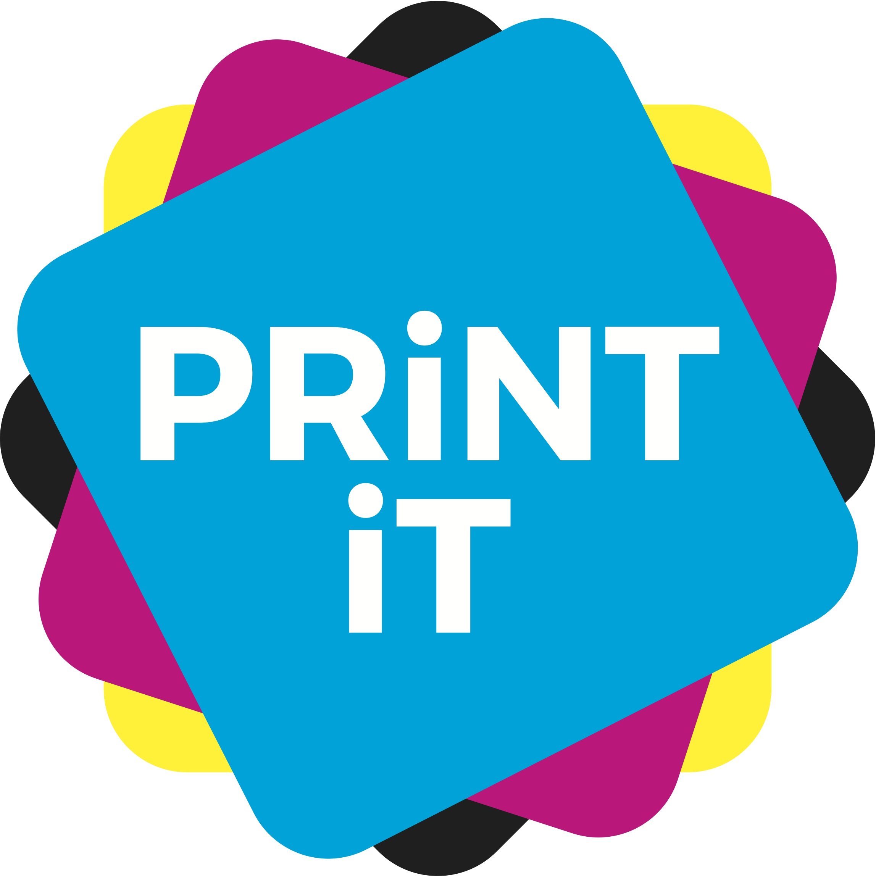
Work sheet

Name:
School:

Unit 1. (Design your logo)

Which category did you choose for your virtual business? Tell us why?

Unit 2. (Design the advert)
Decide on the media channels to be used to promote it. Tell us the reasons why you have chosen these.

Unit 3. (Design the packaging)
Tell us how you are going to produce your packaging – which printing technology you will use and why? Tell us how many you are going to print.

What kind of substrate would you like to use?

Unit 4. (Write the press release and design the invitation)

