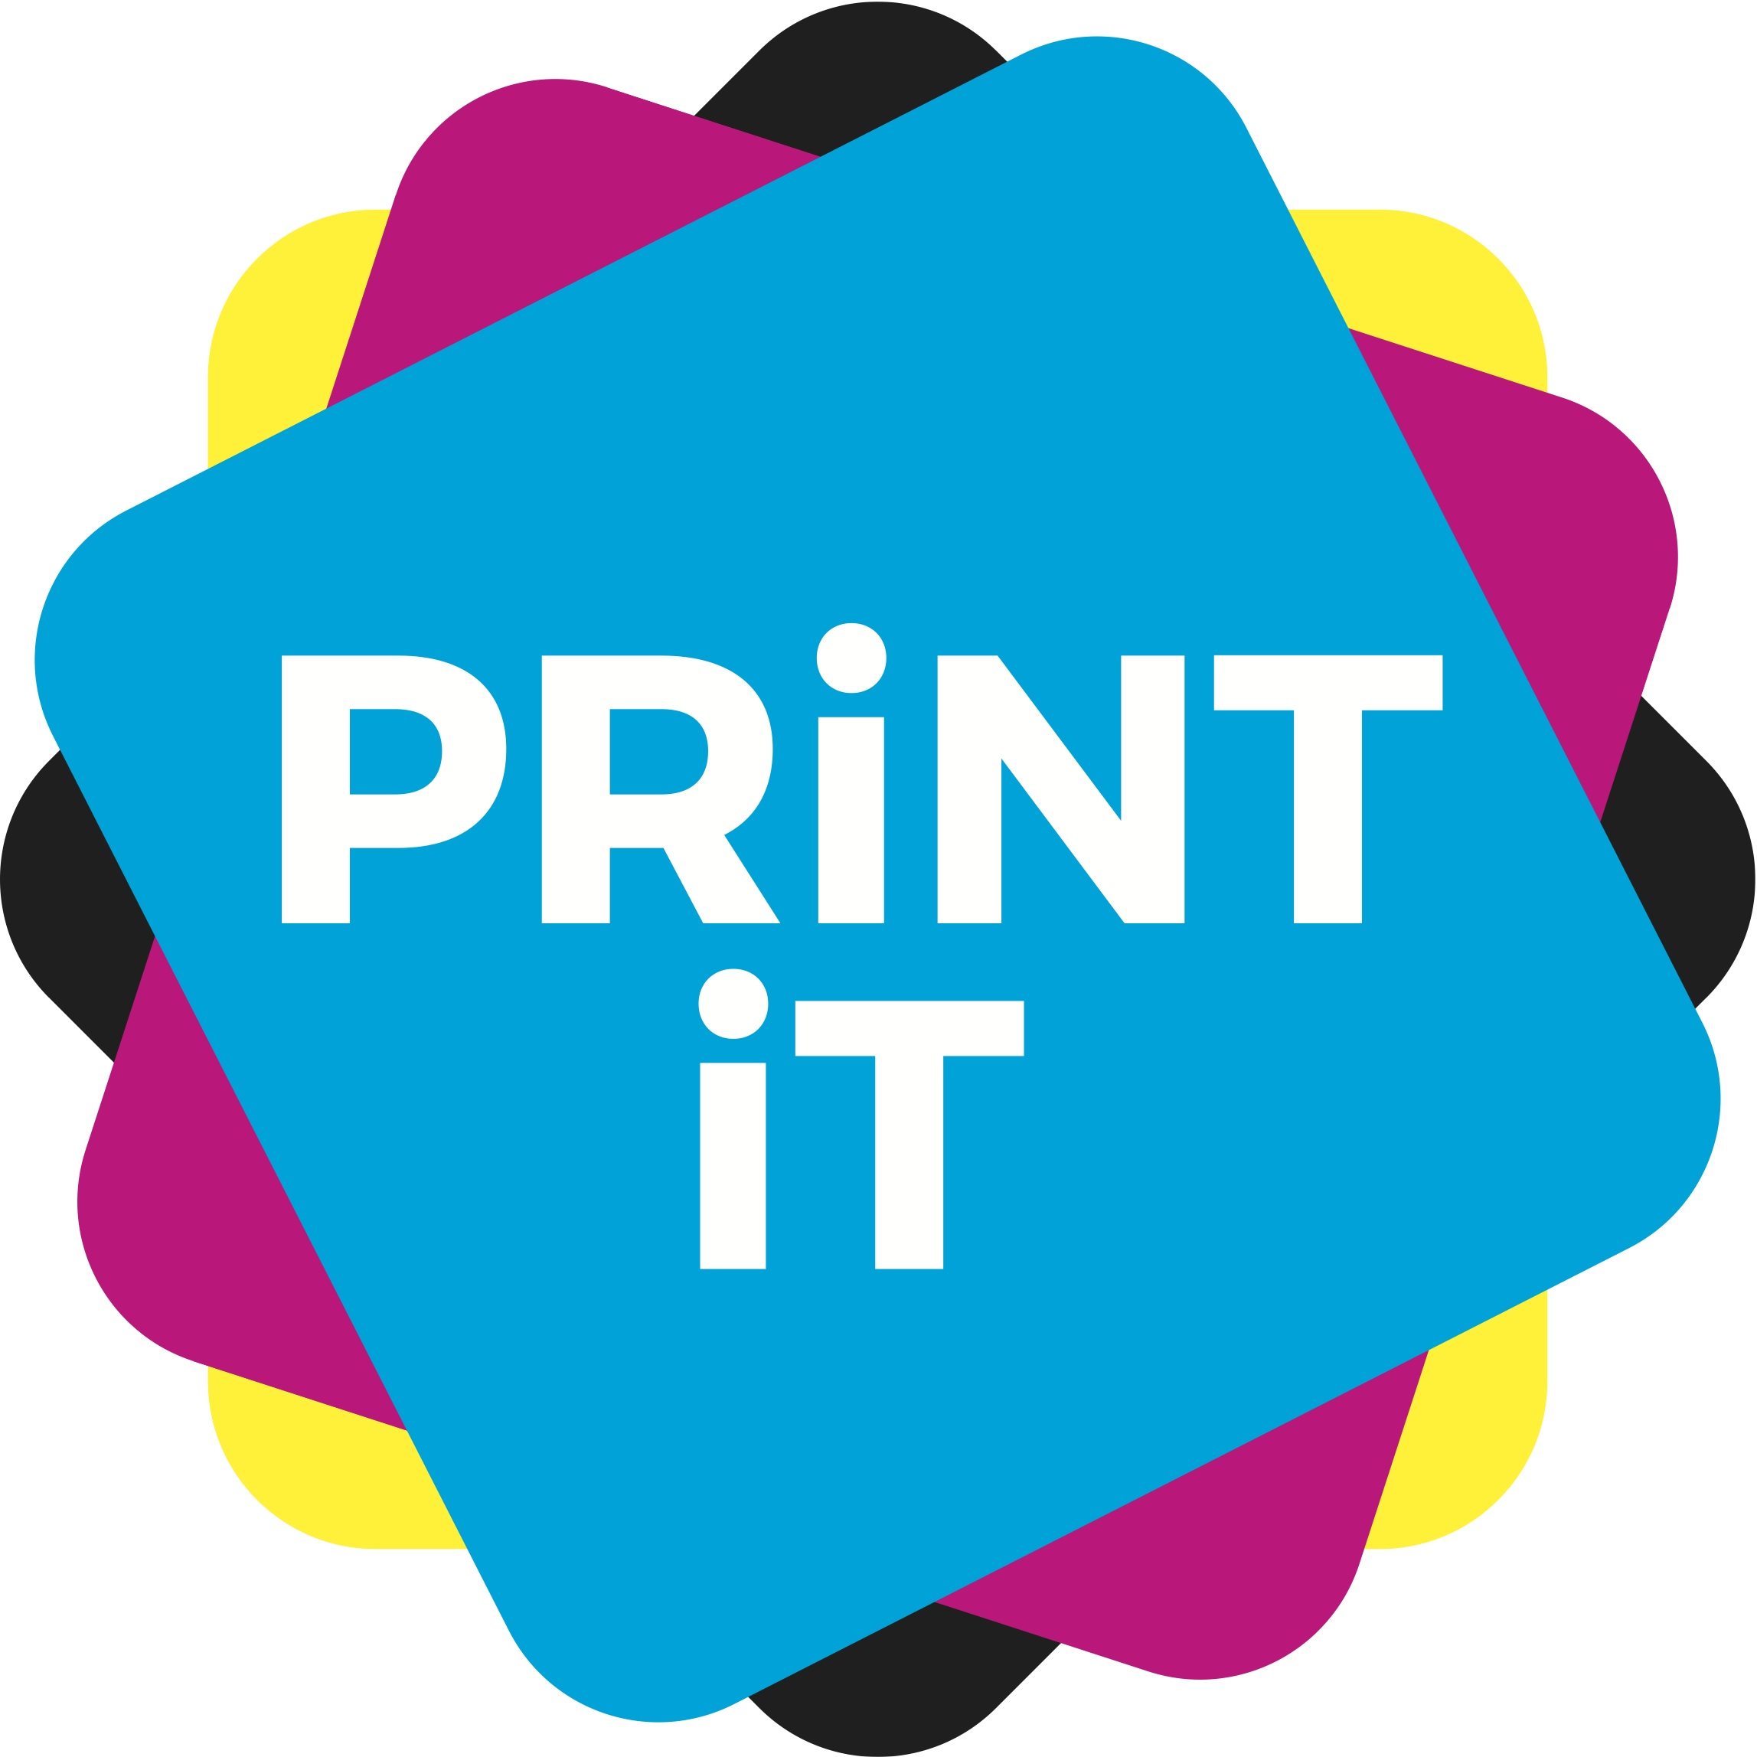
Printing processes – a quick guide
(see ‘printing processes –
the technical bits’ if you want to
know more.

The main commercial printing processes are offset lithography (sometimes just called ‘offset’ or ‘litho’); digital print (which includes Xerography (toner based printing), inkjet, HP Indigo, and others), gravure, flexography, and screen printing.

In both offset and digital, and depending on your printing press, there is the option of running sheetfed (individual sheets), or web (rolls of paper; sometimes called continuous print).

Less commonly used today, there are also specialist print process such as letterpress, pad printing, engraving and Giclee, to name a few.

Photocopying is not a commercial printing process.

By far the most dominant technology, is offset, although digital print is the area that is growing most and will eventually take over in the years to come. So, we shall look at those two in more depth, as the choice in commercial print usually comes down to these two.

In packaging, you would also add flexography into the mix, but only if you were looking at extremely high runs, of lower quality than either digital or offset.

To decide which printing process you need depends on several things.
- The type of product that you are producing – cartons, business cards, reports, books etc.
- The material you will be using.
- The end purpose.
- The special effect or clever addition.
- The ‘run length’ – how many you are going to produce.
- The cost per product.

So, which process should you choose?

Offset:
Offset is a very high quality process that allows the production of many sheets of product in a quick way – average speeds on press range from 11,000 to 16,000 sheets per hour. The vast majority of offset is print on paper substrates.
The process is also cost effective, allowing you to produce runs from say 1000 to 20,000 at a very sensible price.
Sheetfed offset is ideal for any long to medium run project that is commercially based: reports, corporate documents, business cards and stationery, publications and books, direct mail.
Web offset is ideal for longer runs such as high volume direct mail, catalogues, newspapers and long run magazines, and longer urn books.
Depending on your press and its paper handling capabilities, offset can also be used for medium to long runs of packaging,

Digital:
Digital is also high quality – though some machines are not yet as good as offset.
Digital is characterised by the ability to produce extremely short runs – even down to one – very quickly and cost effectively.
It also has the unique ability to add personalisation through variable data, so that each and ever sheet of paper is different.
It is also ideal for reports, corporate documents, business cards and stationery, publications and books, direct mail, by in lower volumes (from one to 1000), although it can handle longer runs, especially web fed machines, but they become less effective than offset.
Digital can be used for the short run production of packaging and labels.

Flexo:
For packaging applications, you could also choose flexographic printing. You would however only choose this technology if you were thinking of printing extremely longs runs of packaging – like a million crisp packets say – so it would not be the first choice of a start up company that wanted to produce a short run of cartons for a new product.

